Department of Computer Science and Engineering (Data Science)
B.Tech. Sem: III Subject: Statistics for Data Science
Experiment 4
Name: SAP ID:
Date: | Experiment Title: Probability Distribution
Aim | To implement Probability Distribution using Python.
Software | Google Colab
Implementation | Using Python solve the following questions given below :  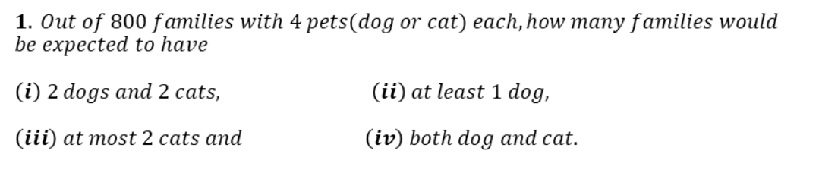  Code:  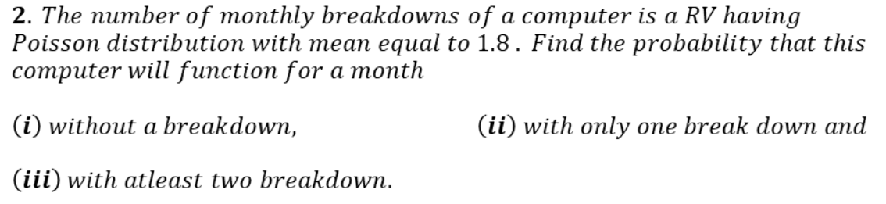  Code:  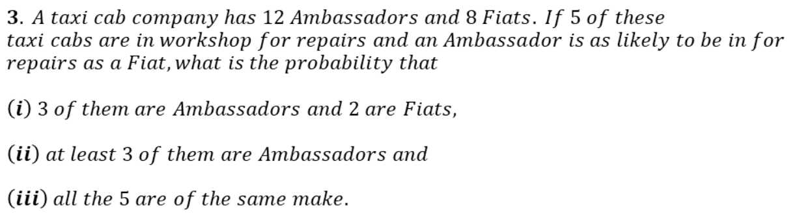  Code:  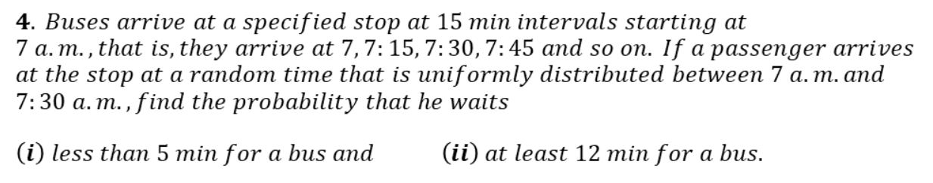  Code:  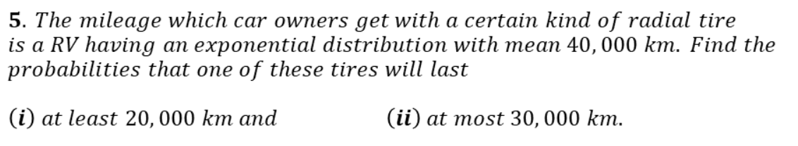  Code:  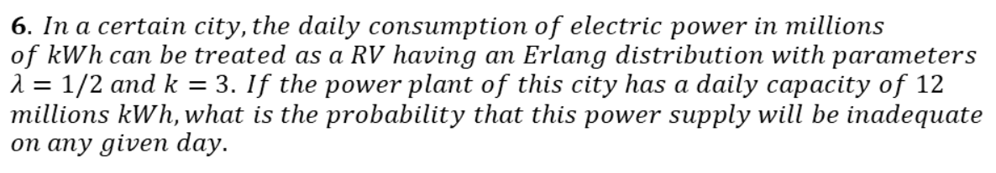  Code:  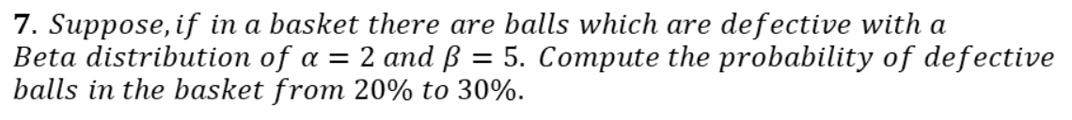  Code:  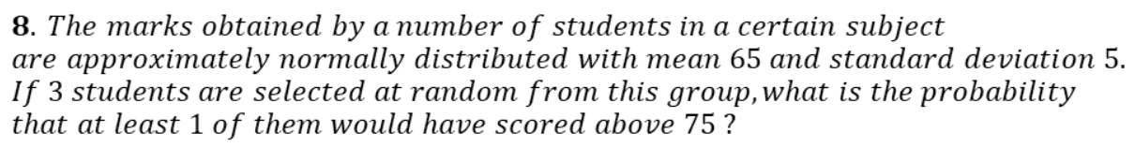  Code:
Conclusion

Signature of Faculty

